Faith Formation Parent Handbook

St. Theresa of the Child Jesus Parish
1230 Merle Hay Road, Des Moines, IA 50311-2098
Parish Office Phone: (515) 279-4654 Parish Office Fax: (515) 277-0838
Parish Web Site: www.sainttheresaiowa.org

Parish Staff

Rev. Mark Neal, Pastor (515) 279-4654 x301 fmneal@sainttheresaiowa.org
Mary Gisler, Parish Manager (515) 279-4654 x303 mgisler@sainttheresaiowa.org
Lauren Schroth, Pastoral Care (515) 279-4654 x308 lschroth@sainttheresaiowa.org
John McMichael, Parish Accountant (515) 279-4654 x305 jmcmichael@sainttheresaiowa.org
Amanda Vande, Parish Secretary (515) 279-4654 x300 avande@sainttheresaiowa.org
Ellen Stemler, School Principal (515) 277-0178 x207 estemler@sainttheresaiowa.org

Faith Formation Staff

Barb Woods (515) 279-4654 x307 bwoods@sainttheresaiowa.org
Adult Faith Form./Music/RCIA Mobile: (515) 210-6649

Jane Ann Becicka (515) 279-4654 x 304 jbecicka@sainttheresaiowa.org
Coordinator of Children’s Faith Formation
Children’s Faith Formation Website http://sainttheresafaithformation.weebly.com/

Megan (Megs) Howes (515) 279-4654 x306 mhowes@sainttheresaiowa.org
Director of Youth Ministry Mobile (515) 720-4060
Youth Ministry Website: http://sttheresayouthministry.weebly.com/index.html
Facebook: http://www.facebook.com/StTheresaYouthGroupDSM

Faith Formation Offices are located in the Parish Office Building.

Parish Office Hours: School year 8:30-4:30; Summer hours 9:00-4:00

Table of Contents

St. Theresa of the Child Jesus staff contact information Page 1

Table of Contents Page 2

Vision statement Page 3

Baptismal promises & Family Involvement Page 3

Catechetical programs Pre-K – high school Pages 4

Registration & Tuition Page 5

Attendance Page 5

Cancellations & Emergency Closings Page 5

Catechists Page 5

Discipline Page 6

Dress Code Page 6

Cell Phones & Electronics Page 6

Curriculum Page 6

St. Theresa Lifelong Faith Formation
Vision Statement

Faith Formation at St. Theresa Parish is an ongoing collaborative ministry. It encompasses all aspects of parish life so that each baptized person will more fully understand his or her faith and live it out at all times and in all places. Faith Formation will be nurtured in our parish by providing a variety of opportunities through prayer, liturgy, service, and catechetical processes.

The Foundations of Faith Formation
Faith Formation applies the Six Essential Tasks of Catechesis:
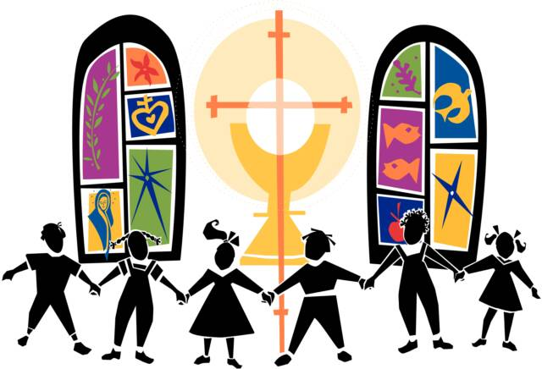
- Knowledge of the Faith
- Liturgical Life
- Moral Formation
- Prayer
- Community
- Missionary Spirit

We also incorporate the four pillars of stewardship, which richly complement the tasks of catechesis:
- Formation
- Prayer
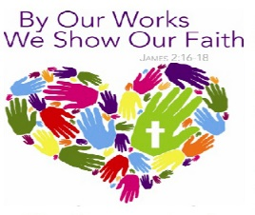
- Hospitality
- Service

Faith Formation is a lifelong process that promotes an environment of Christian values and spiritual growth needed for establishing and maintaining a strong relationship with Jesus.

Family Involvement

At the time of each child’s baptism, parents accept the responsibility and duty of training their child in the knowledge and practice of the Faith. At St. Theresa we recognize parents are the primary educators of their children, sharing their experiences, values, stories, customs and faith. We believe that the holiness a child is exposed to and experiences begins in the home long before the child comes to the parish for faith formation. Faith Formation processes assist and support parents and families in this remarkable task. As partners, we assist in promoting a durable and solid relationship with God, living life as God calls each one to live.

Catechetical programs for Pre-K – high school
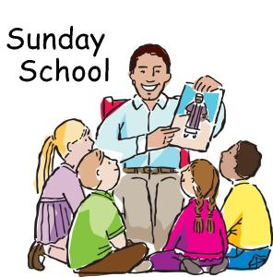
Sunday School (SS) for Pre-Kindergarten and Kindergarten (ages 4-6). Sunday school meets most Sundays from September through April, during 8:30 am Mass. Children must be four years old by September of the current school year to be registered for this program.

Children’s Liturgy of the Word (CLW) meets during 10:30 am Sunday Mass. Children in grades Pre-K through 3rd (ages 4-9) grade are dismissed from the assembly during Liturgy of the Word to participate in the liturgy at their level. No registration required.

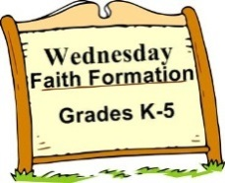
Wednesday Faith Formation (WFF) for Kindergarten through 5th Grade. Meets Wednesday evenings from September to May 6:30-7:30pm at St. Theresa’s Parish School.

First Reconciliation & First Holy Communion preparation is offered to children entering 2nd Grade or older. Sacramental catch up classes are offered for students who have not received sacraments with their peers. Contact the Children’s Faith Formation Coordinator for more information.
Confirmation Preparation beginning in 9th grade.
Edge for 6th-8th grade meets 1st, 2nd and 3rd Wednesday evenings, September to May, 6:30-7:30 pm, in the parish school. Edge is offered to all parish middle schoolers. Edge includes catechetical sessions, service, and social events. It provides parish-based, age appropriate activities and events that reinforce Catholic identity fostered in the home, at St. Theresa School or in the home-school setting. This is led by a team of core team members. An alternating schedule of large group one week and small group the next is used. All middle school students study the same topic. The typical format consists of opening prayer, icebreaker or game, scripture, activity, discussion and closing prayer.
Life Teen for high school meets on the 1st/2nd/3rd Wednesday evenings in the parish hall, September to May, 6:00 to 8:00 pm. Life Teen uses three avenues for learning and faith-sharing: teaching, social and topic/issue sessions. The typical format consists of opening prayer, icebreaker or game, scripture, activity, discussion, and closing prayer. For more information, visit the Youth Ministry Website http://sttheresayouthministry.weebly.com/index.html .

Vacation Bible School Last week of June for students entering grades K-5th
Volunteers: Students entering 6th –adults Information available in the Spring

Registration and Tuition
Faith Formation Registration forms must be completed for each child before they may participate in Faith Formation sessions. Please contact our office for more information.

Tuition Rates:
Registration Fee $15.00 per family Wednesday Faith Formation Tuition Grades K-5
Sunday School $20.00 per child One child $ 60.00
Edge & Life Teen $30.00 per participant Two children $100.00
Three or more children $130.00
No family is charged more than $145 ($130 tuition + $15 registration fee). No family or child will be turned away for financial reasons. There is no charge for Children’s Liturgy of the Word. Families with full-time catechists are only charged the registration fee of $15.00 (tuition fees are waived).

Wednesday Evening Attendance Policy
Consistent attendance is essential for children to gain the maximum benefit from participation in faith formation sessions and to keep our children safe, we ask parents to notify the Faith Formation office before 5:00 pm if their child(ren) will be absent from class on Wednesdays. Please e-mail or phone the faith formation coordinator; do not leave a message on the school phone.

If a child is absent and the office has not been notified, parents will be contacted. For this reason, parents are asked to provide emergency contact information.

For the safety of the children, students are not to be on the parish grounds before 6:20 pm on Wednesdays, unless they are under the supervision of a parent. All students must be picked up promptly upon dismissal at 7:30. The doors on the lower south side of the school are opened at 6:20 pm. *Note: Children are to remain with the hall monitor outside the classroom in the hallway until a catechist or other adult is present in the room.

Cancellations & Emergency Closings
We will follow the St. Theresa school calendar for academic breaks and school closures due to weather or other emergencies. Parents will be notified of cancellation by e-mail. The closings will be announced on KCCI Channel 8. The Parish Website and/or Family Faith Formation website will also be used to make cancellation announcements when possible.

Catechists
Catechists from the parish community are encouraged and trained to offer some of the richness of our Catholic Tradition in the faith formation setting. High school seniors who have been confirmed may be considered catechists at the discretion of the director.

Catechists have the right to expect adequate training and support for the ministry to which they are called. Catechists are required to complete on-line VIRTUS training and a background check to help provide a safe environment for children. Catechists are also encouraged to participate in faith formation opportunities, in-service meetings, and other offerings that enhance their own spiritual lives and catechetical skills.

St. Theresa Parish recognizes the family as the domestic church. Parents/guardians are the principle educators of their children. Catechists assist families in reinforcing the teachings of the Church and help the family to grow in spirituality.

Discipline
In order to foster a Christian atmosphere of hospitality, caring and courtesy and to promote maximum learning in the classrooms the following guidelines are in force:
- It shall be the policy that students attending Faith Formation Programs are expected to treat themselves, one another and all properties with respect and to demonstrate Christian-like conduct at all times.
- Catechists are trained and encouraged to deal with discipline problems in the classroom. When discipline problems arise it is the practice of the program to approach the situation with an attitude of Christian reconciliation.
- Should a discipline problem persist, the catechist has the right to request that a student be excluded from the classroom. In this instance, parents will be contacted.

Dress Code Modest dress should be the guide for all attire.

Cell Phones, iPods, MP-3 players, etc.
All personal electronic devices must be out of sight and not in use once students enter the building for catechesis. Devices that are out will be safely held by the catechist, hall monitor or director until the session is over.

Curriculum Faith Formation is built around the vision and philosophy described on page 3
Sunday School uses the Allelu! Program
Children’s Liturgy of the Word uses “Children Celebrate” from Pflaum
WFF uses “Call to Faith” from Harcourt Religious Publishers
Edge and Life Teen use curricula provided by Life Teen

Sacramental Preparation
Sacraments provide times of joy and celebration for individual families and the entire parish community.
Normative ages for reception of the sacraments are second grade for both First Reconciliation and First Eucharist. The normative grade for Confirmation is 10th grade.
Consistent attendance in a faith formation program or Catholic school for the years prior to and the year of a sacrament is a prerequisite for celebrating First Reconciliation, First Eucharist and Confirmation. Readiness to receive the sacrament of confirmation will be assessed for students who have not participated in a faith formation program after celebrating First Eucharist. Supplementary formation prior to reception of Confirmation may be required.

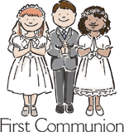
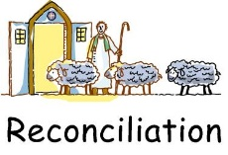
NOTE: Parents of children preparing to receive sacraments are to attend sacramental preparation meetings to receive support in their roles as primary educators and to learn what their children will be studying in the process. Please contact the Coordinator of Children’s Faith Formation (Reconciliation and Eucharist) or Youth Minister (Confirmation) if you are unable to attend the scheduled meetings.

