Faith Formation Parent Handbook
St. Theresa of the Child Jesus Parish
1230 Merle Hay Road, Des Moines, IA 50311-2098
Parish Office Phone: (515) 279-4654 Parish Office Fax: (515) 277-0838
Parish Web Site: www.sainttheresaiowa.org
Office Hours: 7:30 - 4:00, Monday – Friday

Parish Staff

Rev. Ray Higgins, Pastor (515) 279-4654 x301 frhiggins@sainttheresaiowa.org
Mary Gisler, Parish Manager (515) 279-4654 x303 mgisler@sainttheresaiowa.org
Lauren Schroth, Pastoral Care (515) 279-4654 x308 lschroth@sainttheresaiowa.org
John McMichael, Parish Accountant (515) 279-4654 x305 jmcmichael@sainttheresaiowa.org
Sue Fitzpatrick, Parish Secretary (515) 279-4654 x300 sfitzpatrick@sainttheresaiowa.org
Ellen Stemler, School Principal (515) 277-0178 x207 estemler@sainttheresaiowa.org

Faith Formation Staff

Barb Woods (515) 279-4654 x307 bwoods@sainttheresaiowa.org
Adult Faith Form./Music/RCIA Mobile: (515) 210-6649

Jane Ann Becicka (515) 279-4654 x 304 jbecicka@sainttheresaiowa.org
Coordinator of Children’s Faith Formation
Children’s Faith Formation Website http://sainttheresafaithformation.weebly.com/

Megan (Megs) Howes (515) 279-4654 x306 mhowes@sainttheresaiowa.org
Director of Youth Ministry Mobile (515) 720-4060
Youth Ministry Website: http://sttheresayouthministry.weebly.com/index.html
Facebook: http://www.facebook.com/StTheresaYouthGroupDSM

Mass Times
Daily 6:30 am, 8:30 most Fridays during the school year
Saturday 4:30; Sunday 8:30, 10:30, 4:30
Holydays check bulletin or website for current schedule

Reconciliation
1st, 3rd, 5th Saturday 3:00-4:00 pm
2nd, 4th Saturday 8:30-9:30 am
Other times available by appointment

Table of Contents

St. Theresa of the Child Jesus parish staff contact information Page 1

Table of Contents Page 2

Vision statement Page 3

Baptismal promises & Family Involvement Page 3

Catechetical programs Pre-K – high school Pages 4

Curriculum Page 5

Registration & Tuition Page 5

Attendance & drop off/pick up policy Page 5

Emergency Closings & Cancellations Page 6

Catechists Page 6

Discipline Page 6

Dress Code Page 6

Cell Phones & Electronics Page 6

Sacramental Preparation Page 7

St. Theresa Lifelong Faith Formation
Vision Statement

Faith Formation at St. Theresa Parish is an ongoing collaborative ministry. It encompasses all aspects of parish life so that each baptized person will more fully understand his or her faith and live it at all times and in all places. Faith Formation will be nurtured in our parish by providing a variety of opportunities through prayer, liturgy, sacraments, service, and catechesis.

The Foundations of Faith Formation
Faith Formation applies the Six Essential Tasks of Catechesis:
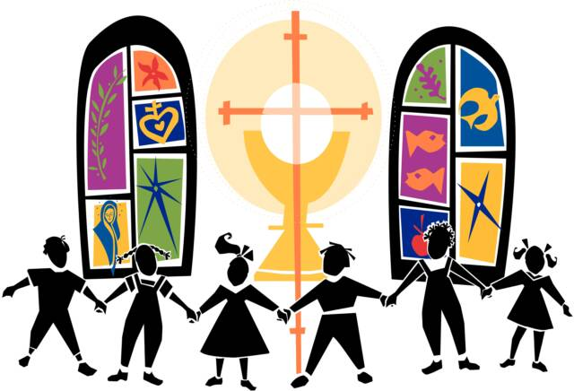
- Knowledge of the Faith
- Liturgical Life
- Moral Formation
- Prayer
- Community
- Missionary Spirit

We also incorporate the four pillars of stewardship, which richly complement the tasks of catechesis:
- Formation
- Prayer
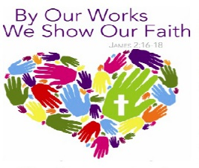
- Hospitality
- Service

Faith Formation is a lifelong process that promotes an environment of Christian values and spiritual growth needed for establishing and maintaining a strong relationship with Jesus.

Family Involvement

At the time of each child’s baptism, parents accept the responsibility and duty of teaching their child in the knowledge and practice of the Faith. At St. Theresa Parish we recognize parents are the primary educators of their children, sharing their experiences, values, stories, customs and faith. We believe that the holiness a child experiences begins in the home long before the child comes to the parish for faith formation classes. Parish Faith Formation assists and supports parents and families in this remarkable task. As partners, we assist in promoting a durable and solid relationship with God, living life as God calls each one to live.

Catechetical programs for Pre-K – High School
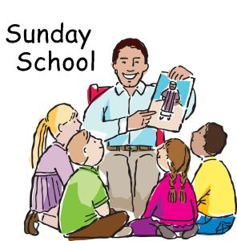
Sunday School (SS) for Pre-Kindergarten and Kindergarten (ages 4-6). Sunday School meets most Sundays from September through April, during 8:30 am Mass. Children will learn about God and His love for them through songs, bible stories, crafts and prayer. Please register.

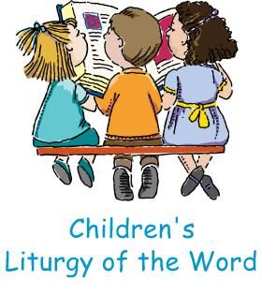
Children’s Liturgy of the Word (CLW) meets during 10:30 am Sunday Mass. Children in grades Pre-K through 3rd (ages 4-9) grade are dismissed from the assembly during Liturgy of the Word to participate in the liturgy at their level. No registration required.

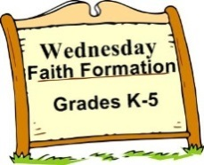
Wednesday Faith Formation (WFF) for Kindergarten through 5th Grade. Meets most Wednesday evenings from September to May 6:30-7:30pm at St. Theresa’s Parish School. Please register.

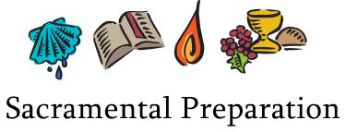
First Reconciliation & First Holy Communion preparation is offered to children entering 2nd Grade or older. Sacramental catch up classes are offered for students who have not received sacraments with their peers. Contact the Children’s Faith Formation Coordinator for more information.
Confirmation Preparation beginning in 9th grade. Please register.

Edge for 6th-8th grade usually meets 1st, 2nd and 3rd Wednesday evenings, September to May, 6:30-7:30 pm, in the parish school. Edge is offered to all parish middle schoolers. Edge includes catechetical sessions, service, and social events. It provides parish-based, age appropriate activities and events that reinforce Catholic identity fostered in the home, at St. Theresa School or in the home-school setting. This is led by a team of core team members. An alternating schedule of large group one week and small group the next is used. All middle school students study the same topic. The typical format consists of opening prayer, icebreaker or game, scripture, activity, discussion and closing prayer.
Life Teen for high school usually meets on the 1st/2nd/3rd Wednesday evenings in the parish hall, September to May, 6:00 to 8:00 pm. Life Teen uses three avenues for learning and faith-sharing: teaching, social and topic/issue sessions. The typical format consists of opening prayer, icebreaker or game, scripture, activity, discussion, and closing prayer. For more information, visit the Youth Ministry Website http://sttheresayouthministry.weebly.com/index.html .

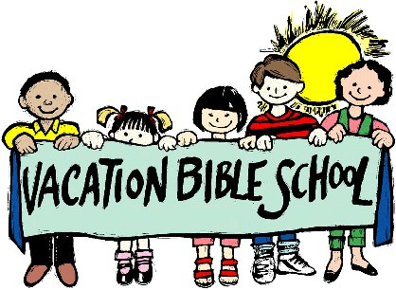
Vacation Bible School is held in the summer. Watch bulletin for details.

Curriculum To support parents in the faith formation of their children, St. Theresa Catholic Parish uses the following classroom materials:

Sunday School -- Allelu! Program published by Our Sunday Visitor
Children’s Liturgy of the Word -- “Children Celebrate” published by Pflaum Publishers
Reconciliation & Eucharist – God’s Gift published by Loyola Press
WFF -- Call to Faith published by Our Sunday Visitor
Edge and Life Teen use curricula provided by Life Teen

Registration and Tuition
Faith Formation Registration forms must be complete for children to participate in Faith Formation sessions. Forms available in the parish office and online.
Tuition Rates
Sunday School $20.00 per child, no registration fee

Faith Formation Tuition Grades K-10
Registration Fee $15.00 per family
One child $ 50.00
Two children $100.00
Three or more $135.00
Family maximum $150 ($135 tuition + $15 registration fee)
Confirmed high school students are free

No family or child will be turned away for financial reasons. Contact the faith formation coordinators for more information. Families with full-time catechists are only charged the registration fee of $15.00 (tuition fees are waived).

Wednesday Evening Attendance Policy
Consistent attendance is essential for children to gain the maximum benefit from participation in faith formation sessions and to keep our children safe, we ask parents to notify the Faith Formation office before 5:00 pm if their child(ren) will be absent from class on Wednesdays. E-mail or phone the faith formation coordinator for children in grades K-5 and the youth minister for children in grades 6-12. Do not leave a message on the school phone.

Drop off and pick up
Drop off K-2nd grade parents, please wait with your child outside the classroom until your catechist arrives. 3rd-5th grade students, wait with the downstairs hall monitor until your catechist arrives.

Pick up K-2nd grade parents meet your child outside their classroom. Make sure the catechist knows that you have picked up your child. 3rd-5th grade parents, pick up your child in the downstairs hallway. Make sure your catechist knows that you have picked up your child.

For the safety of the children, students may be on the parish grounds if they are under the supervision of a parent or guardian.

Closings & Cancellations
Emergency closings or cancellations will be announced on the Parish Website or KCCI Channel 8. Since our parish families come from a wide range of area cities, please exercise caution based on your own area’s safety.

Catechists
Catechists from the parish community offer the richness of our Catholic Tradition in a classroom setting. Catechists are expected to be in good standing with the Church. They are required to complete on-line VIRTUS training and a background check to help provide a safe environment for children. Catechists are also encouraged to participate in faith formation opportunities, in-service meetings, and other offerings that enhance their own spiritual lives and catechetical skills.
Confirmed high schoolers may be assistant catechists at the discretion of the director.

Discipline
In order to foster a Christian atmosphere of hospitality, caring and courtesy and to promote maximum learning in the classrooms, the following guidelines are used:
- It shall be the policy that students attending Faith Formation Programs are expected to treat themselves, one another and all properties with respect and to demonstrate Christian-like conduct at all times.
- If discipline problems arise it is the practice of the program to approach the situation with an attitude of Christian reconciliation.
- Should a discipline problem persist, the catechist has the right to request that a student be excluded from the classroom. In this instance, parents will be contacted.

Dress Code Modest dress should be the guide for all attire.

Cell Phones, iPods, MP-3 players, etc.
All personal electronic devices must be out of sight and not in use once students enter the building for catechesis. Devices that are out will be safely held by the catechist, hall monitor or director until the session is over.

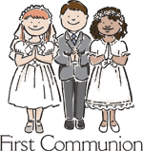
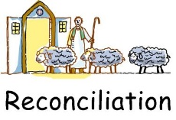
Sacramental Preparation

Sacraments provide times of joy and celebration for individual families and the entire parish community.

Children usually receive First Reconciliation in the fall and First Eucharist in the spring of 2nd grade.

Confirmation is usually celebrated in the spring of 10th grade.

Consistent attendance in a Catholic parish or school faith formation program for the years prior to receiving sacraments is important for celebrating First Reconciliation, First Eucharist and Confirmation. Children who have missed the usual age of sacramental reception are most welcome to begin wherever they are in their faith journey. It is never too late to accept Jesus’ gifts of grace in the sacraments!

Readiness to receive the sacrament of confirmation will be assessed for students who have not participated in a faith formation program after celebrating First Eucharist. Supplementary formation prior to reception of Confirmation may be required.

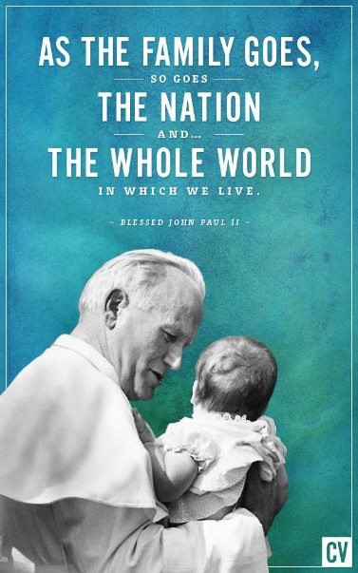
NOTE: Parents, the parish supports you as your child’s primary educator. In addition to sharing practical details about procedures for the sacramental day, we want to partner with you to deepen our adult understanding of the Faith so that we can best guide our children as they grow in their own relationship with Jesus. Contact the Coordinator of Children’s Faith Formation (Reconciliation and Eucharist) or Youth Minister (Confirmation) if you are unable to attend the scheduled meetings so we can set up an alternate meeting. God bless our families!

From St. John Paul the Great

